Fall Protection Plan Template
Completed by: |  |  |  |  |  | Job Task:
Company: |  |  |  |  |  | Date:
Site: |  |  |  |  |  | Valid to:
Scope of Work:
POTENTIAL FALL HAZARDS |  |  |  |  |  |  | IDENTIFY SYSTEM(S) TO USE
 |  | Work over 10 Feet |  |  |  |  |  |  | Guardrails
 |  | Elevated Work Platform |  |  |  |  |  |  | Temporary Floor Covering
 |  | Working over surface/thing potential injury |  |  |  |  |  |  | Control zone
 |  | Over tank, pit, vat w/ hazardous material |  |  |  |  |  |  | Fall Arrest
 |  | Excavation |  |  |  |  |  |  | Vertical Lifeline
 |  | Other (specify): |  |  |  |  |  |  | Other (specify):
EQUIPMENT INSPECTION
Lanyard Serial #: |  |  |  |  |  |  | Harness Serial #:
 |  |  | PASS (✓) |  | FAIL (X) |  |  |  |  |  |  |  | PASS (✓) |  |  | FAIL (X)
Webbing |  |  |  |  |  |  | Webbing/Straps
Snap Hooks |  |  |  |  |  |  | D-Ring(s)
Connectors |  |  |  |  |  |  | Buckles
Labels |  |  |  |  |  |  | Labels
Energy Absorber |  |  |  |  |  |  | Fall Indicator
CLEARANCE REQUIREMENTS FOR FALL PROTECTION SYSTEM(S): This must be calculated. The distance the worker would fall must be less than the distance to the nearest object/surface below. Additional considerations must be given for horizontal lifelines, vertical lifelines, self-retractable etc. Consult with manufacturer's specifications.
FREE FALL DISTANCE: This must not be greater than 1.2 m (4') if there’s no shock absorber. It must not be greater than that permitted by the fall protection manufacturer. (Refer to Manufacturer's Specifications for maximum allowable free fall for individual lanyard).
Free Fall Distance (FFD):  FFD = Lanyard Length (L) +/- Distance from D-Ring to Anchor Point (D)  FFD = _______ ft +/- _______ ft  FFD = _______ ft  Minimum Clearance Required (MCR) from Anchorage Point:  Length of Lanyard (L): ____  Deployment of Energy Absorber (E): ____  D-Ring Slide (D): ____  Height of Worker (H): ____  Safety Factor (S): ____  MCR = L + E + D + H + S = _______ |  |  |  |  |  |  |  |  |  |  |  |  |  | 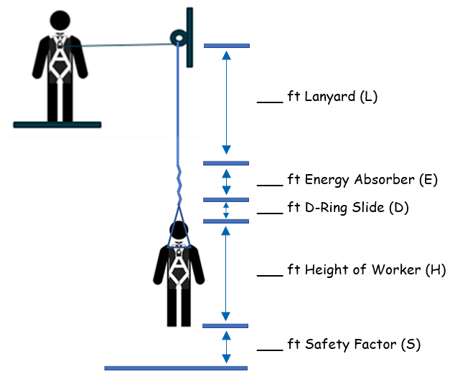
RESCUE PROCEDURES: The Plan must specify how the worker will be rescued if they fall and is suspended. Examples include ladders, aerial devices, self-rescue fall protection equipment (suspension steps that deploy when the shock-absorber deploys, self-rescue SRLs, etc.) Workers must be trained in rescue procedures and conduct practice drills.
Emergency Contact Name: |  |  |  |  |  |  |  | Emergency Contact Number:
First Aid Personnel Name: |  |  |  |  |  |  |  | First Aid Personnel Number:
Rescue Plan:

ANSWER QUESTIONS PRIOR TO COMMENCEMENT OF WORK:
- Is required first aid equipment readily available on site?  - Are numbers for local emergency medical and fire services available (if needed)?  - Are emergency exits and/or muster stations identified?  - Is there an identified primary and secondary method of communication?  - Are workers trained to perform work at height?  - Are the procedures for inspection, set up, use, and removal attached?  - Is the site-specific hazard assessment attached?  - Are there additional considerations needed for the site i.e. safety equipment, barricades, etc.? If so, specify: |  |  |  |  |  |  |  |  |  |  |  |  |  |  | □ Yes □ No  □ Yes □ No  □ Yes □ No  □ Yes □ No  □ Yes □ No  □ Yes □ No  □ Yes □ No  □ Yes □ No
SIGNATURES Ensure all workers sign below & check Yes or No to acknowledge their responsibilities and to confirm understanding of the job task.
Worker Name (Print) |  |  |  |  | Do you understand your responsibilities? |  |  |  |  |  | Worker Signature
 |  |  |  |  | □ Yes □ No
 |  |  |  |  | □ Yes □ No
 |  |  |  |  | □ Yes □ No
 |  |  |  |  | □ Yes □ No
 |  |  |  |  | □ Yes □ No
 |  |  |  |  | □ Yes □ No
 |  |  |  |  | □ Yes □ No
 |  |  |  |  | □ Yes □ No
Supervisor Signature: |  |  |  |  |  |  |  |  |  |  |  | Date:

