LANYARD INSPECTION

Model: ______________________ Serial # ______________________ Date of Manufacture: ___________________

Type of Lanyard:
Energy/Shock Absorbing Flat Web Tubular Energy Absorbing Tie-Back/Wrap-Back
Double- Legged Cable Rope Chain Positioning
Other: __________________________________________________________________________

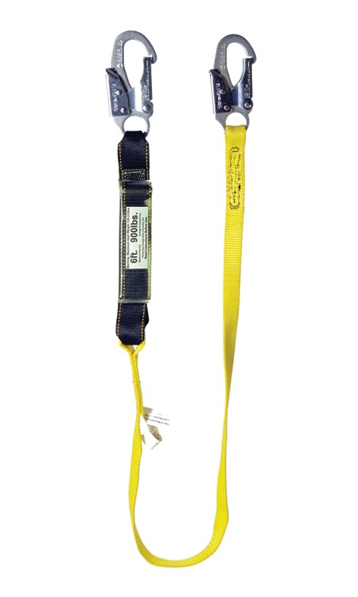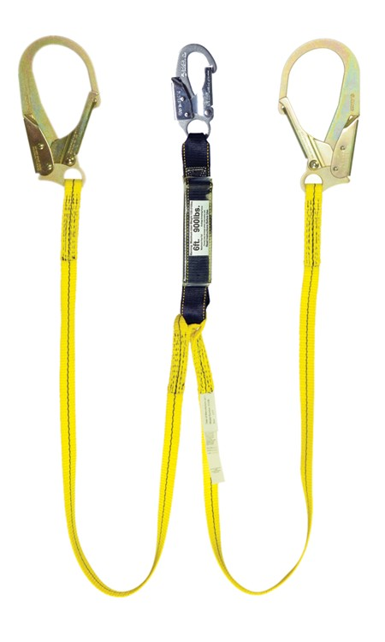

WEBBING | P | F | Note #

Name of Inspector __________________________________
Broken, Missing, or Loose Stitching
Termination (stitch or splice)
Webbing Length
Cuts
Burns
Holes
Deterioration
Paint Damage

Signature of Inspector _____________________________

Date _____________

NOTES

LANYARD

Snap Hook

Label Energy Absorbing Pack

Termination

ENERGY ABSORBING PACK
Webbing

Integrity of Cover
Signs of Deployment
Signs of Damage

Y-LANYARD

SNAP HOOKS & D-RINGS
Function of Snap Hook Locking Gate
Body of Hook or Rivets
Corrosion
Pitting
Nicks

Snap Hook

LABELS & MARKINGS
Legible Label
Appropriate CSA Markings
Date of First Use

DEFINITION OF TERMS

Deterioration - Eaten or worn away by chemicals

Pitting - A small indentation in a surface

Nicks - A shallow notch, cut, or indentation on an edge or surface

Label
Energy Absorbing Pack

Termination

Webbing

